Week 9 - Final WESO Practice

Part A - Computing Basics (10 points)
1) What is the name of the unit that executes instructions and performs calculations in a computer?
a. CPU
b. Input
c. Memory
d. Output

2) What is the name for something that connects computers together so that they can share data?
a. Hard Drive
b. Algorithm
c. Network
d. Operating System

3) Which one of the following is NOT a programming language?
a. Scratch
b. Python
c. Java Script
d. Flow Chart

4) Which of the following is NOT a computer peripheral?
a. Keyboard
b. Random Access Memory
c. Webcam
d. Printer

5) What is the name for an error in a computer program that makes it function incorrectly?
a. variable
b. sprite
C. bug
D. mouse

Part B - Computing “Theory”

1. Convert 99 from decimal to binary.

a. Show your steps for conversion. (3 pts.)
b. Write the final answer and circle it. (2 pts.)

2. The following is the algorithm for a certain task.

i. ‘numbers’ is a list of positive numbers
ii. ‘m’ is a number, initially set to 0
iii. for each number in the list, if the number is greater than ‘m’, set m to be equal to the number
iv. after checking all the numbers in the list, print ‘m’

a. Explain in a sentence or two what this algorithm is doing. What is the final result it is computing? (3 pts.)
b. Show how the algorithm would run if ‘numbers’ = [13, 5, 22, 7] Show each step and circle the final answer that would print. (2 pts.)

3. There is a farm that has cows, chickens, and goats. They want to install a system that will sort the animals into their respective pens when they come in from the pasture. The animals will enter one at a time and stand on a scale. Depending on their weight, the correct door will open--one to the chicken coop, one to the cow barn, and one to the goat barn. The chickens all weigh between 6 and 12 pounds, The goats are all 60-100 pounds, and the cows all weigh at least 300 pounds.
Draw a flowchart to show how the system will work. Keep in mind you can take only one coin at a time and place it in the appropriate box before you pick another one. (5 pts)

Part C - Practical Computing

Scoring:
30 points total, based on the following breakdown:
o 10 points for a correct algorithm that uses proper programming constructs
o 10 points for a working program
o 5 points for attention to precision
o 5 points for creativity and/or efficiency (tie-breaker)

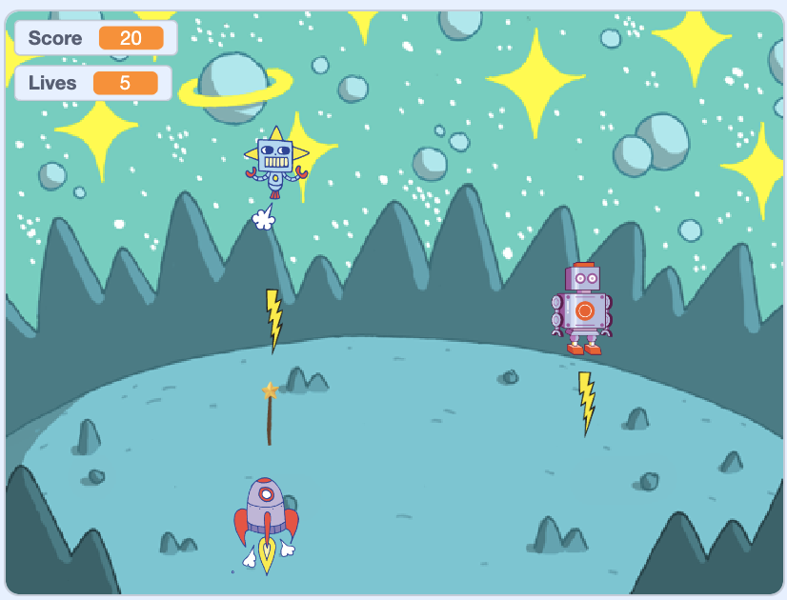

Create a Breakout Game that meets the following specifications:
- The player controls a spaceship that can only move left and right along the bottom of the screen
- Two robots fall from the top of the screen--one is faster than the other. They always move straight down and start at the top of the screen, but they start at a different X position each time they reappear.
- The robots shoot lightning bolts down at the player. If a bolt hits the spaceship the player loses one life.
- If a robot hits the spaceship, the player loses one life.
- The player can shoot laser beams (wands) at the robots. If they hit the fast robot, they get 10 points. If they hit the slow robot, they get 5 points.
- The game is over when the player has 0 lives left.

